SQL PROJECT

Library Database Analysis

Please find below the steps to work on the library store project.
Start by creating all the required tables with the required constraints which will help you to create the relationship between the tables. Make sure to derive the required constraints you make use of the schema diagram from the project folder. Below you will find the hints and help required to create all the tables.
👉 Kindly click on the Dataset to check and download
Data Model: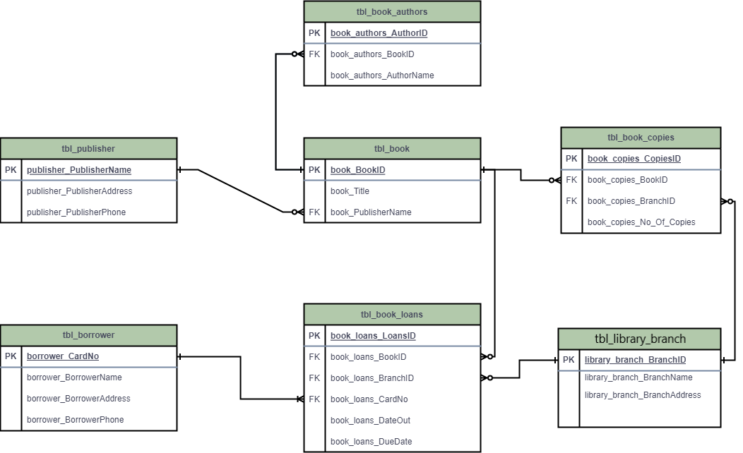
SQL Query
-- Table: tbl_publisher
CREATE TABLE tbl_publisher (
publisher_PublisherName VARCHAR(255) PRIMARY KEY,
publisher_PublisherAddress TEXT,
publisher_PublisherPhone VARCHAR(15)
);
-- Table: tbl_book
CREATE TABLE tbl_book (
book_BookID INT PRIMARY KEY,
book_Title VARCHAR(255),
book_PublisherName VARCHAR(255),
FOREIGN KEY (book_PublisherName) REFERENCES tbl_publisher(publisher_PublisherName)
);
-- Table: tbl_book_authors
CREATE TABLE tbl_book_authors (
book_authors_AuthorID INT PRIMARY KEY AUTO INCREMENT,
book_authors_BookID INT,
book_authors_AuthorName VARCHAR(255),
FOREIGN KEY (book_authors_BookID) REFERENCES tbl_book(book_BookID)
);
-- Table: tbl_library_branch
CREATE TABLE tbl_library_branch (
library_branch_BranchID INT PRIMARY KEY AUTO INCREMENT,
library_branch_BranchName VARCHAR(255),
library_branch_BranchAddress TEXT
);
-- Table: tbl_book_copies
CREATE TABLE tbl_book_copies (
book_copies_CopiesID INT PRIMARY KEY AUTO INCREMENT,
book_copies_BookID INT,
book_copies_BranchID INT,
book_copies_No_Of_Copies INT,
FOREIGN KEY (book_copies_BookID) REFERENCES tbl_book(book_BookID),
FOREIGN KEY (book_copies_BranchID) REFERENCES tbl_library_branch(library_branch_BranchID)
);
-- Table: tbl_borrower
CREATE TABLE tbl_borrower (
borrower_CardNo INT PRIMARY KEY,
borrower_BorrowerName VARCHAR(255),
borrower_BorrowerAddress TEXT,
borrower_BorrowerPhone VARCHAR(15)
);
-- Table: tbl_book_loans
CREATE TABLE tbl_book_loans (
book_loans_LoansID INT PRIMARY KEY AUTO INCREMENT,
book_loans_BookID INT,
book_loans_BranchID INT,
book_loans_CardNo INT,
book_loans_DateOut DATE,
book_loans_DueDate DATE,
FOREIGN KEY (book_loans_BookID) REFERENCES tbl_book(book_BookID),
FOREIGN KEY (book_loans_BranchID) REFERENCES tbl_library_branch(library_branch_BranchID),
FOREIGN KEY (book_loans_CardNo) REFERENCES tbl_borrower(borrower_CardNo)
);

Key things to consider while creating database:
- While importing the data carefully check whether the column names are matching to csv file column names or not.

Task Questions
- How many copies of the book titled "The Lost Tribe" are owned by the library branch whose name is "Sharpstown"?
- How many copies of the book titled "The Lost Tribe" are owned by each library branch?
- Retrieve the names of all borrowers who do not have any books checked out.
- For each book that is loaned out from the "Sharpstown" branch and whose DueDate is 2/3/18, retrieve the book title, the borrower's name, and the borrower's address.
- For each library branch, retrieve the branch name and the total number of books loaned out from that branch.
- Retrieve the names, addresses, and number of books checked out for all borrowers who have more than five books checked out.
- For each book authored by "Stephen King", retrieve the title and the number of copies owned by the library branch whose name is "Central".

Project Presentation Template
As part of this project, you are required to create and present the analysis findings. Use the following PowerPoint template to structure your presentation:
👉Click here to find the PPT Template for the Project Presentation

Submission
After completion of the project Zip the .sql query file and PPT upload the zip file with your name and batch number. In LMS.

